JS – includes() vs contains()

Node.contains only applies to DOM nodes and only accepts DOM nodes as their search element.

String.includes and Array.includes returns boolean true or false. This is roughly equivalent to Node.contains but do not exist as "includes" on nodes.

**Closure** – used for accessing outer function’s scope from an inner function 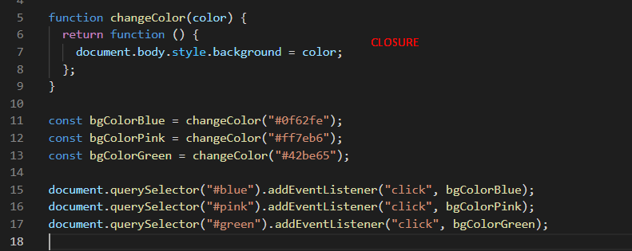

Why we can’t use useEffect in if statements: because every use hook is bound to a linked list in an order. Using if statements will break the order of execution.